This lab also will be done  using Putty and ssh to log into your account.  I will both be grading this paper as well as logging in to see your work.  You will also be using a screen capture to capture your work.

At the command prompt type: *vimtutor*

Instead of reading the text (boring!) you can use the [vimtutor](http://vimdoc.sourceforge.net/htmldoc/usr_01.html#vimtutor) to learn your first Vim commands. This is a 30 minute tutorial that teaches the most basic Vim functionality hands-on. Be sure to read as you move along this tutorial. You will need to know how to use it throughout the rest of the semester.

In step 1.6 they ask you to type vim tutor (notice the space between vim and tutor) This is the name of the file you will create called “tutor” To receive a grade I should see that file with some text in it. It is not the same as typing vimtutor.

When finished start this lab.

Make a directory called *module7*.  All work, unless otherwise noted, will be put there.

1. Touch three empty files named project1, project2 and project 3

2. Create another file using redirection and the echo command.  *Type:  echo Mary had a little lamb > project4*

3. Create another file called *project22* using vi with the following text in it (type it):

  The vi editor is a full screen editor and has three modes of operation:

1. Command mode commands which cause action to be taken on the file
2. Insert mode in which entered text is inserted into the file
3. Ex-mode (or last line) in which you can do things like save and set numbers

Save the file and use cat to read it. Insert a screenshot of that HERE

4. From your home directory copy a file that is in the /tmp directory called *cathyfile* into your module7 directory.

How did you do this?

cp /tmp/cathyfile ~/module7

Once the file is there use vi to add a line to the end of the file that says: Done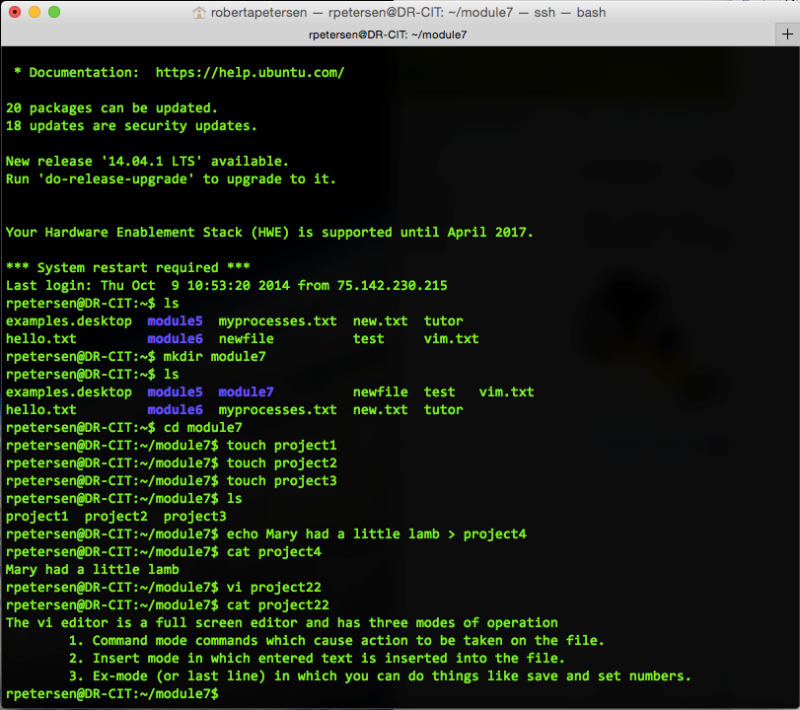

Save the file

5. Using wildcards do a long listing that shows the results of only the file *project22*. How did you do this?

ls -l *22

6. Make another directory called *projects* inside of your module7 directory

Copy all the project files into this directory using only one command and a wildcard. How did you do this?

cp project* projects

Using one command and wild cards, remove all the projects files that have one character only after project. *project2*2 should remain there.

How did you do this?

rm project?

7. Use the move command to rename the *cathyfile* to *yournamefile* (replace yourname with you first name). Again, how did you do this?

mv cathyfile rpetersen

8. Type the command to display all the processes on your system (there are several different options you can use) but instead of displaying it on your screen pipe it to the command to count the lines (your output should show lines only). Take a screenshot of the command with the results you get and put it HERE.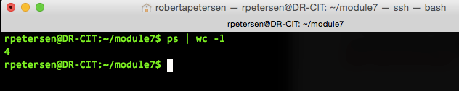

9. In the /etc directory display on the files that end in .conf

How did you do this?

ls /etc/*.conf

Now take get that same output from the /etc directory and redirect it to a file in your module7 directory called *configuration*.

How did you do this?

ls /etc/*.conf > ~/module7/configuration

10. Use VIM to add your name to the top of the file configuration. Save it.

11. Type the command that shows you the date and redirect the output to a file called *date.txt*

12. Using ONE command line, type the command to do a long listing of the /var directory and pipe it to wordcount AND take that results and send it to a file called *var.txt* How did you do this? Put a screenshot HERE

ls -l /var | wc > var.txt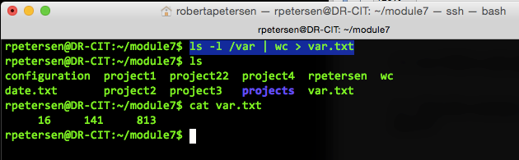

13. Open *configuration* in vi and turn on the numbers using the ex-mode. Take a screenshot of that and place it HERE.

